What is Phlebotomy?
Phlebotomy is the practice of drawing blood for transfusions or testing for abnormalities in the blood. The people who are trained to draw blood are called phlebotomists. They are trained to draw blood from animals and humans for “tests, transfusions, donations, or research.” Phlebotomists collect blood by a venipuncture, finger sticks, and a heel stick specifically for infants.
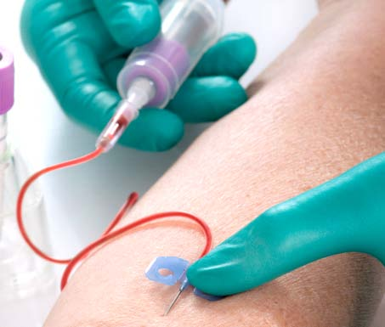
Simply, phlebotomy means to cut into a vein. The term comes from the Greek word “phlebos” which means vein. And the Greek word “tome” which means “to cut”. The procedure of cutting into the vein, or “puncturing” the vein is called “venipuncture”. A finger stick is “pricking” or cutting the tip of the finger so a small drop of blood can be drawn. For example, like when a person with diabetes performs a finger stick to test blood sugar. This is also called a “dermal puncture”. A heel stick is the same as a finger stick, just on the heel instead of the tip of a finger.
Figure 1: Drawing and collecting blood, http://www.stenbergcollege.com/phlebotomy-course.html
The history of Phlebotomy is believed to date back 1400 B.C. This is because an Egyptian tome painting shows a leach being applied to the skin of a sick person. This practice of using leaches was still around in the 1800s. Hippocrates believed that this practice, also known as bloodletting, returned the body to a balanced state by removing “bad blood”. Bloodletting also used a process “venesection” in which the vain is priced with a sharp object to drain blood. The sharp object may be a needle or a “lancet”, very sharp blade used for cutting a vain. This was popular in the 1800s but was preformed even before that in fact George Washington died because of bloodletting. During the late1980s early 1990s, the phlebotomy profession came as a result of technology in greater laboratory tests. Initially only medical technicians collected blood. During this time, a delegated group of trained professionals “Phlebotomist” came to be.
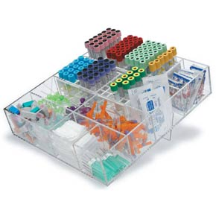
The phlebotomist is responsible for the collection and transportation of blood specimens to the laboratory for processing of tests. A doctor will order the time and collection of the blood specimen test. The different kinds of test require different collection tubes. The different tubes have different kinds of chemicals in them, most have anticoagulants in them which is to stop blood clotting.
Figure 2: Drawing Station, http://www.marketlabinc.com/product.asp?P_ID=4407

http://phlebotomists.com/html/article_1.html
http://en.wikipedia.org/wiki/Phlebotomy
Encyclopedia Britannica
Encyclopedia Britannica

