Baby Strollers
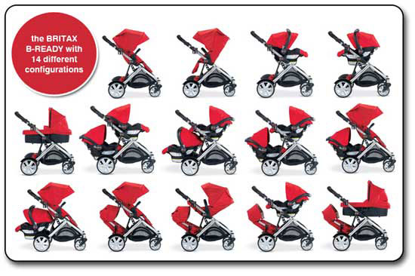
Formerly known as baby buggies, baby strollers an essential item for any parent. Once a sign of social status and only available to the rich, it is now a common necessity for any parent. Over the years there have been several improvements to the baby buggy. Some of the advancements are strollers that fit more than one child, jogging stroller, umbrella stroller, mountain buggy, and strollers that can be pulled by a bike. In today’s stroller world, you have 5-point harnesses, canopies, cup holders, safety bars, shock suspension, wheels that fill with air, and strollers that fit your infant car seat. You’ll find lightweight strollers for one-handed folding for easy storage. To help you decide what you would like in a stroller, here are the features in detail.
Figure 1: http://gerberbabycontest.net/baby/baby-stroller-coupon-january-2012-britax-b-ready-stroller.html

- Pram/Carriage Strollers-a fully reclining seat that allows your newborn to lie flat. Some can convert into toddler’s strollers as well. This stroller type is good for taking a leisurely walk.
- Standard Strollers-are made of a durable sturdy frame with a fully reclining seat for you to use thru your child’s infancy to toddlerhood. They are easiest to push and steer on smooth surfaces like mall floors and sidewalks.
- Lightweight Strollers-are a great option when traveling or running errands. Most lightweight strollers don’t offer a fully reclining seat so they are best for children who are one years old or older. They are typically less expensive than most other strollers. Excellent choice for a second stroller.
- Umbrella Strollers- an umbrella stroller are most likely to meet your stroller needs since they are an inexpensive stroller that is also compact and lightweight. Their small size and simple design makes it easy to navigate through narrow walkways. They are by far the easiest strollers to store, since they can fit into most any vehicle trunk when folded.
- Jogging Strollers-are the Ideal choice for parents who are serious joggers or runners. Jogging strollers have a lightweight frame with air-filled tires. There is an emergency wrist strap on a jogging stroller that ensures your child’s safety by preventing the stroller form getting away from you during your run.

- All-Terrain Strollers-looks just like a jogging stroller, but has a different use in mind. An all-terrain stroller has a swiveling front wheel, which makes it easier to steer and maneuver than a jogging stroller. This increased maneuverability is a good choice for parents who need a stroller to be used in outdoor situations and in malls and other shops.
- Combo Strollers-a combo stroller is an ideal stroller choice for parents who want a versatile stroller that can be used for their child’s infancy and throughout toddlerhood. A combo stroller consists of a toddler stroller base and a coordinating infant bassinet. Most combo strollers include high-end extras such as extra seat padding and cup holders as well as convenience features like adjustable height handles.
- Travel Systems-is a practical stroller option for parents with a newborn. The travel system includes a compatible infant car seat and toddler stroller in one system.
- Bike Trailers-are perfect option for parents who want to take their children along when they go bicycling. The children are completely covered when riding in a bike trailer. A bike trailer is considered a safer alternative to the child bicycle seat. Some bike trailers can convert into a walking or jogging stroller as well.
- Double Strollers-are for parents with twins or those with a toddler with a baby on the way. Since they hold two children comfortably, double strollers make it possible for one parent to take both children on outings. They are available in lightweight, traditional and jogging options.
- Triple Strollers-is for traveling with triplets or three small children more convenient. Triple strollers are available in lightweight, umbrella, standard, and jogging. The right triple stroller can make it possible for one parent to get out of the house with all three children
- Quadruple Strollers-a stroller with four seats for parents with quadruplets.

